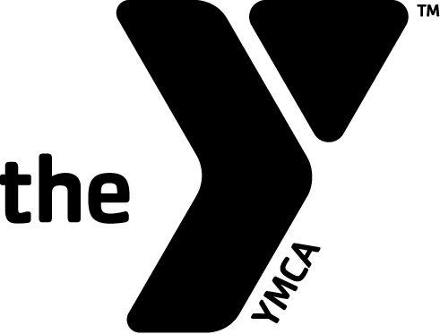
Job Title: Regional Property Director Grade: 505
Job Code: FC8902 Service Area: Member Loyalty

Overview

Our mission: To put Christian principles into practice through programs that build healthy spirit, mind, and body for all.

Our cause: At the Y, strengthening community is our cause. Every day, the Y works side-by-side with our neighbors to make sure everyone, regardless of age, income, or background, has the opportunity to learn, grow, and thrive.

Our position: The Y is a leading nonprofit organization that is committed to strengthening communities through youth development, healthy living, and social responsibility.

LEADERSHIP Competencies: Values, Inclusion, Relationships, Communication, Decision Making, Quality Results, and Functional Expertise.

General Description: Provide oversight and maintenance all facilities, properties, and grounds at assigned locations. Completes projects as assigned.

Knowledge & Skills:
High school diploma or equivalent required; college degree preferred. A minimum of four years of work experience in facilities management required. Must have familiarity with OSHA standards, emergency plans, equipment purchasing and lease contracts, maintenance management, housekeeping. Strong supervisory skills, PC skills and budgeting experience necessary. Ability to prioritize and handle multiple tasks in a fast-paced environment required.

PRINCIPAL RESPONSIBILITIES:
- Interpret, communicate, and promote Y mission, goals, and objectives to department employees, volunteer leaders, members, and the community.
- Promote, foster, and support the Y’s commitment to access, inclusion and engagement for all by engaging diverse populations in a welcoming environment.
- Support branch/department initiatives related to membership retention and Annual Giving goals.
- Build and maintain positive relationships with members and staff.
- Lead and coordinate ARC approved projects for all assigned locations.
- Perform approved repairs including but not limited to plumbing carpentry, flooring, painting, landscaping, and housekeeping.
- Provide leadership in major facility, aquatics, and property repairs.
- Maintain safe and high-quality standards, for all assigned locations.
- Lead and evaluate facility and property management including staffing, contractors, cleanliness, repairs, and supplies.
- Ensure proper use and methods of ARC approved cleaning materials, supplies, equipment, building fixtures, and equipment. Must be able to operate custodial equipment including scrubbers, strippers, extractors to support branch custodians.
- Manage budgets in assigned areas of responsibility including timely and accurate forecasting and budget analysis.
- Manage ARC approved preventive maintenance and inspection schedule on all equipment and major systems for assigned locations.
- Serve as a member of the Property and Facilities Cabinet
- Accountable for consistently updating ARC approved system of records, reports, and inventory in assigned areas. Responsible for updating, communication and closeout of all work orders and projects in Facility Dude.
- Responsible for scheduled “on-call” evenings and weekends.
- Serve as staff liaison between ARC and branch leadership regarding property and facilities decisions and projects.
- Support branch staff and custodians in maintenance, housekeeping, and branch custodial projects, such as carpet cleaning, high dusting, tile scrubbing, etc.
- Administer maintenance contract services for branches assigned, ensuring adherence to the contract and approving payment.

END RESULT:
- The YMCA of Greater Richmond facility and maintenance projects are completed on-time and on-budget.
- The YMCA of Greater Richmond property team provides high quality maintenance and facility services for the benefit of members and program participants.

Physical Requirements:
Must be able to stand and/or sit for extended periods of time, and sufficient strength to lift and carry 50 pounds. Ability to carry out maintenance duties including general repair and cleaning. Use of a ladder and various tools essential, as well as the ability to walk up and down stairs frequently, as well as regular bending, kneeling, and standing as needed in a daily shift. Will travel between branch locations throughout the YMCA of Greater Richmond, as well as to supply locations and may be exposed to weather conditions prevalent at the time. Must have sufficient strength, agility, and dexterity to perform all required tasks and the ability to work outdoors in different temperatures. Sound level may be high. Must be able to communicate effectively with others.

Employee Name: __________________________

Employee Signature: __________________________ Date: ___________

This job description is a summary of this position and other responsibilities may be assigned as needed. The YMCA of Greater Richmond reserves the right to review and modify this position as needed.

